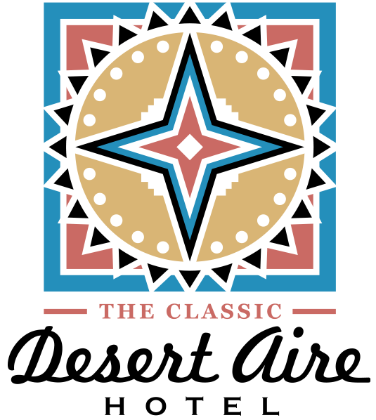

THE CLASSIC DESERT AIRE HOTEL @1021 S White Sands Blvd Alamogordo, NM 88310

(Odd Fellows & Rebekahs) March 2024

The Classic Desert Aire Hotel is proud to offer a special rate to your guests. Please review the details and have all guests contact us to commence booking. Rooms are based on availability: To take advantage of this special rate plan please have guests book as soon as possible and mention “Odd Fellows”.

Room Type | Standard Rate | 10% one night | 15% multi nights stay
KNS | $99 + tax | $89.10+ tax | $87.12 + tax
QNS | $95.00 + tax | $85.50 + tax | $83.60 + tax
QQ | $109.00 + tax | $98.10 + tax | $95.92 + tax

*Please be advised that any additional guests wishing to stay in a room over the room max, will be charged an additional 10.00 per guest fee. Guests must declare all pets at check-in. There is a $15 per pet per night fee with a 2 pet max per room. Other room types are available, please call the hotel for details. A valid credit card must be presented at the time a reservation is made.

This Special Rate is the best rate plan for your guests to take advantage of. Keeping that special rate plan in mind, if any guest needs to cancel please contact the front desk no later than 24 hours before arrival to avoid any cancellation penalties. A valid credit or debit card is required to hold all rooms. Rooms are based on availability. Please provide Promo Code “ Odd Fellows & Rebekahs” when calling for reservations. Please if your group agrees with this rate plan have them reach out as soon as possible as we have rooms based on availability as we have several groups in town this month.

Please call The Classic Desert Aire Hotel directly at 575-437-2110 for these special rates. Your guests will also receive access to our hot breakfast, WiFi and fitness room.

We here at The Classic Desert Aire look forward to having your guests relax with us. We take pride in offering efficient and friendly service. We are a family-owned and operated hotel with one goal in mind.. to make our guests happy.

Best Regards,

Jesse Muniz
jesse@desertaireinc.com
575-437-2110

